Determining Event flow / Task pipeline for pick-up and drop drone delivery

* User registration & subsequent log-in:

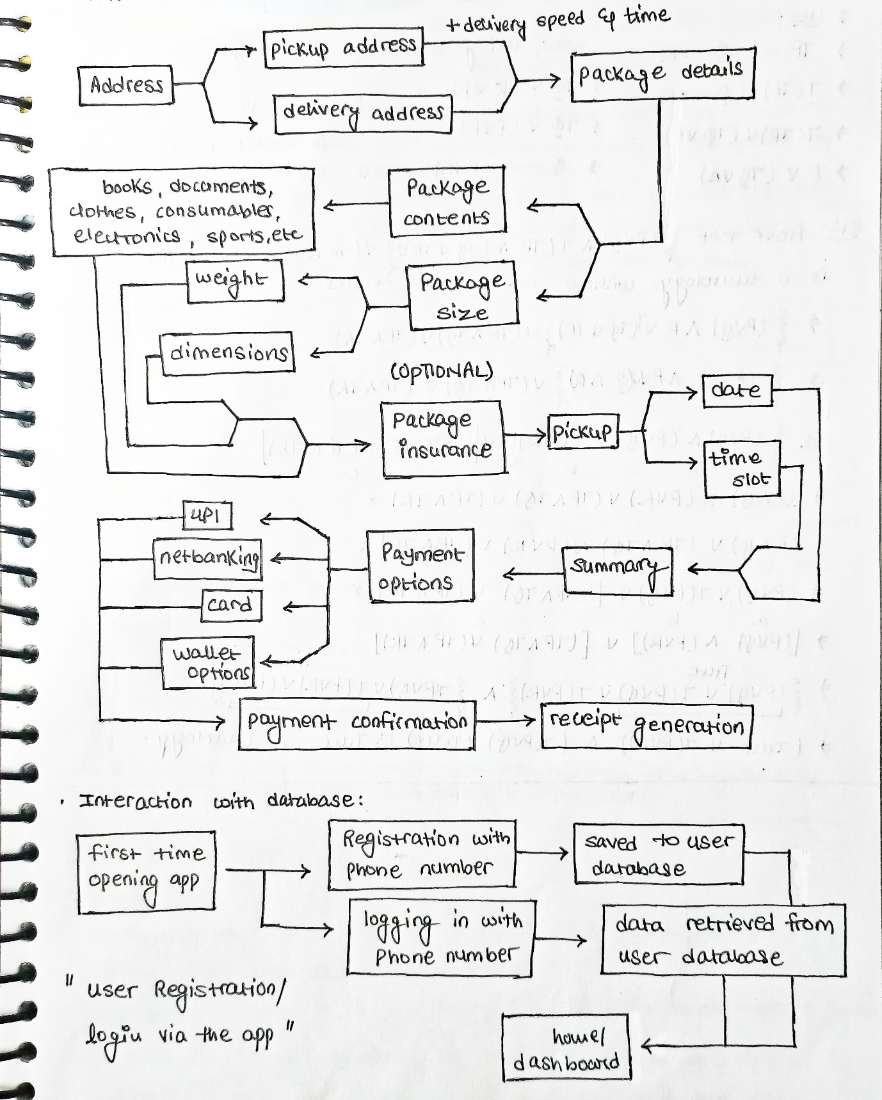

* Client interaction with app user interface:



* App’s back-end interaction with the fly-zone database:

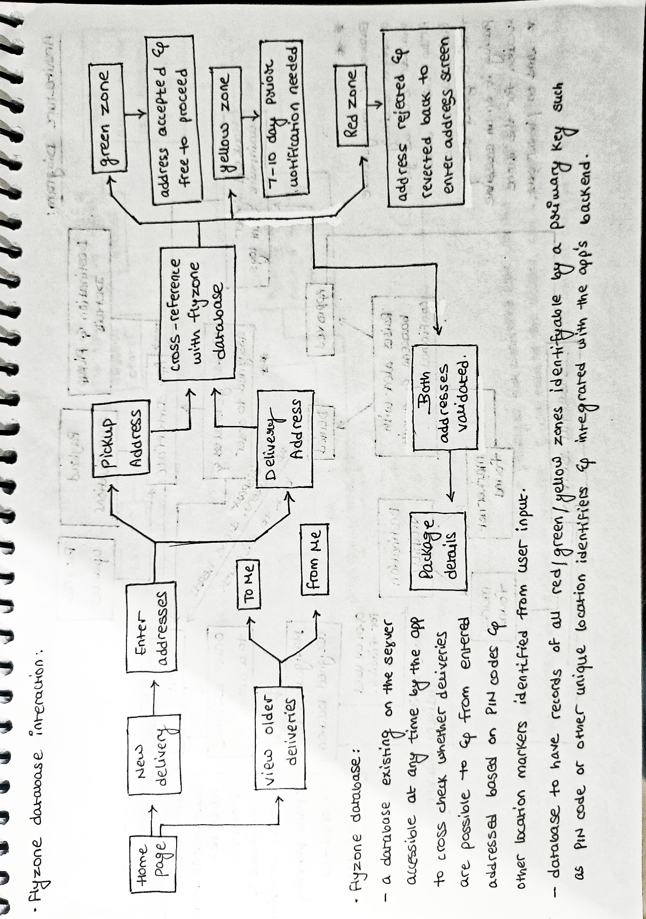

* Drone selection & dispatch criteria:

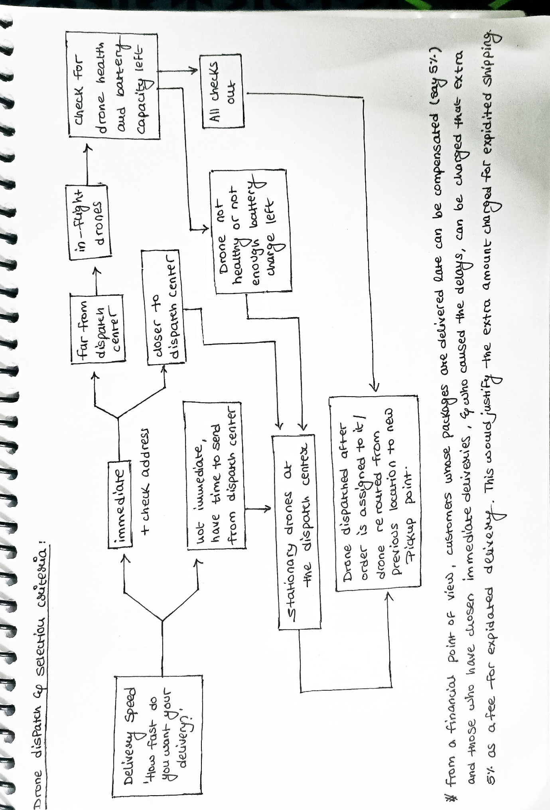

* Overall architecture diagram:

